DoctorDayPlan v2.0
Project Scope
In Scope
DoctorDayPlan v1.0 is a doctor-centric practice management platform designed for independent doctors operating one or more clinics. The application aims to digitize the daily workflow of a doctor's practice by replacing manual appointment registers, paper prescriptions, and dependency on front-desk staff for routine scheduling tasks.
The system provides two user roles:
- Doctor (Primary User)
- Patient (Secondary User)

1. User Requirements
These describe what each user expects from the system.
Doctor Requirements
- The doctor shall be able to securely log in to the system.
- The doctor shall be able to manage their professional profile.
- The doctor shall be able to manage multiple clinic locations.
- The doctor shall be able to configure working schedules and availability.
- The doctor shall be able to view and manage appointment requests.
- The doctor shall be able to manage the live consultation queue.
- The doctor shall be able to record consultation details and prescriptions.
- The doctor shall be able to access complete patient medical histories.
- The doctor shall be able to search patient records.
- The doctor shall be able to monitor daily appointments through a dashboard.
Patient Requirements
- The patient shall be able to register and log in securely.
- The patient shall be able to view doctor profiles and clinic availability.
- The patient shall be able to book appointments.
- The patient shall be able to track appointment status.
- The patient shall be able to check in for scheduled appointments.
- The patient shall be able to monitor their live queue position.
- The patient shall be able to access consultation history.
- The patient shall be able to download digital prescriptions.

Modules Specification
Module 1: Authentication & Access
Purpose:
Provides secure user authentication and authorization for both doctors and patients. This module acts as the entry point of the application and ensures that only authenticated users can access protected resources.
Responsibilities:
- Authenticate doctors and patients using JWT.
- Register new patient accounts.
- Securely store passwords using bcrypt hashing.
- Implement role-based access control (Doctor and Patient).
- Validate user identity before granting access to other modules.
- Allow authenticated users to manage their profile information.

Module 2: Practice Management (Profile, Clinics & Scheduling)
Purpose:
Allows doctors to digitally set up and manage their medical practice, making appointment scheduling completely automated based on their availability.
Responsibilities:
- Create and update the doctor's professional profile.
- Manage one or more clinic locations.
- Configure weekly working schedules.
- Define consultation slot duration.
- Mark unavailable dates such as holidays or leave.
- Automatically generate available appointment slots.
- Allow patients to view clinic information and available slots.

Module 3: Appointment Management
Purpose:
Manages the complete lifecycle of appointments between patients and doctors, from booking until consultation.
Responsibilities:
- Allow patients to book appointments.
- Display available appointment slots.
- Allow patients to cancel appointments before confirmation.
- Allow patients to check in upon arrival.
- Enable doctors to accept, reject, or reschedule appointments.
- Display today's appointments to the doctor.
- Prevent duplicate bookings for the same time slot.
- Maintain appointment status throughout its lifecycle.

Module 4: Live Queue & Real-Time Updates
Purpose:
Maintains a real-time consultation queue that keeps both doctors and patients updated throughout the consultation process.
Responsibilities:
- Generate the live consultation queue from checked-in appointments.
- Display the current patient being consulted.
- Show queue position and estimated waiting time.
- Allow doctors to call the next patient.
- Allow doctors to skip patients when required.
- Remove patients from the queue after consultation.
- Synchronize queue updates instantly using Socket.io.
- Notify doctors and patients about important appointment events.

Module 5: Consultation & Medical Records
Purpose:
Provides a digital consultation workspace where doctors can maintain patient medical records and generate prescriptions.
Responsibilities:
- Display complete patient medical history.
- View previous diagnoses and prescribed medicines.
- Record new diagnoses and consultation notes.
- Add medicines and dosage instructions.
- Generate downloadable PDF prescriptions.
- Maintain a complete consultation history.
- Allow doctors to search patient records.
- Allow patients to access their medical history and prescriptions.

Technology Stack
Category | Technologies Used | Purpose
Frontend | React.js, React Router, Tailwind CSS v4, Axios, Socket.IO Client, SheetJS xlsx | User interfaces, routing, REST communication, real-time updates, responsive styling, and Excel exports.
Backend | Node.js, Express.js, Mongoose, JWT, bcrypt, Socket.IO, PDFKit | REST APIs, persistence, authentication, authorization, live queues, and PDF generation.
Database | MongoDB with Mongoose | Document storage with embedded user profiles and referenced clinic, appointment, consultation, and medicine collections.
Notifications | Nodemailer SMTP, Twilio REST API | Email and SMS delivery when credentials are configured; demo outbox otherwise.
Testing | Jest, mongodb-memory-server | Backend integration and queue-handler tests with an isolated MongoDB test server.
Development Tools | Git, GitHub, Postman, Vite | Version control, API testing, frontend development, and static analysis.
Deployment Options | Vercel, Render, MongoDB Atlas | Deployment options for the frontend, backend, and hosted database.

Use Case Diagram Module wise:

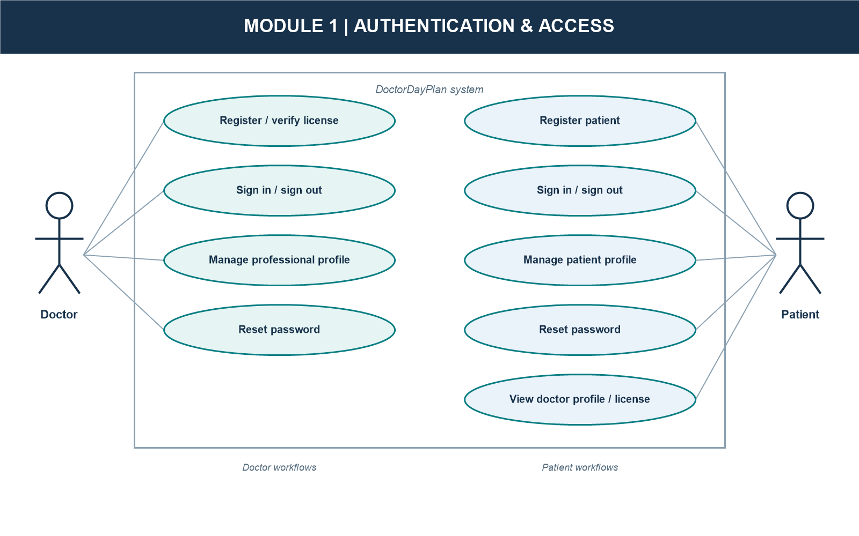

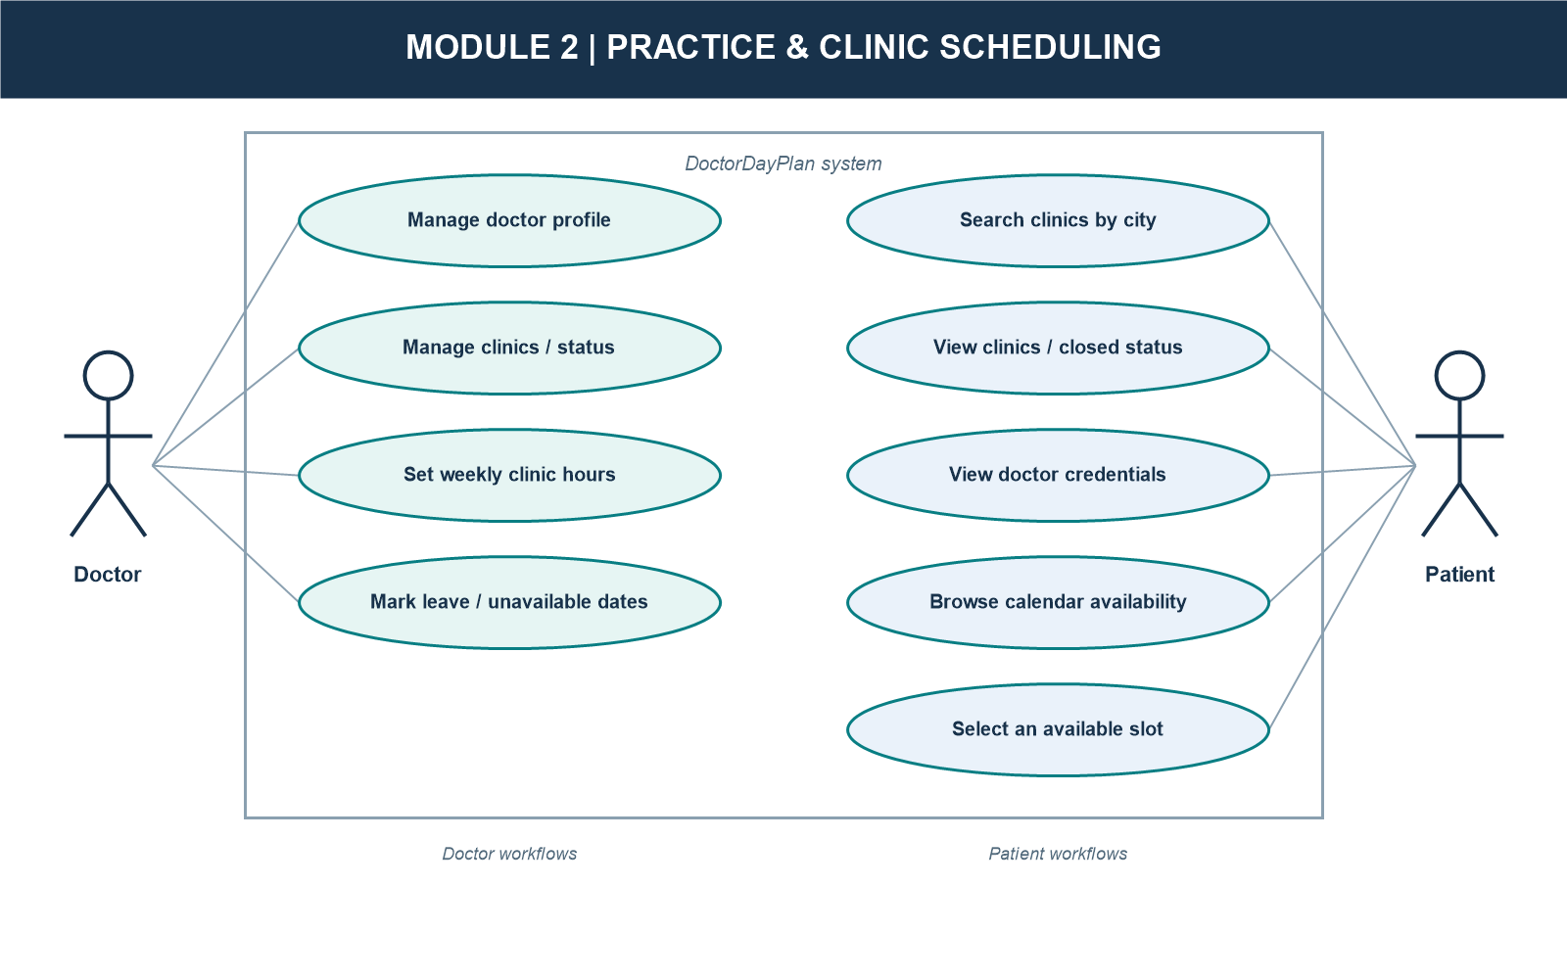

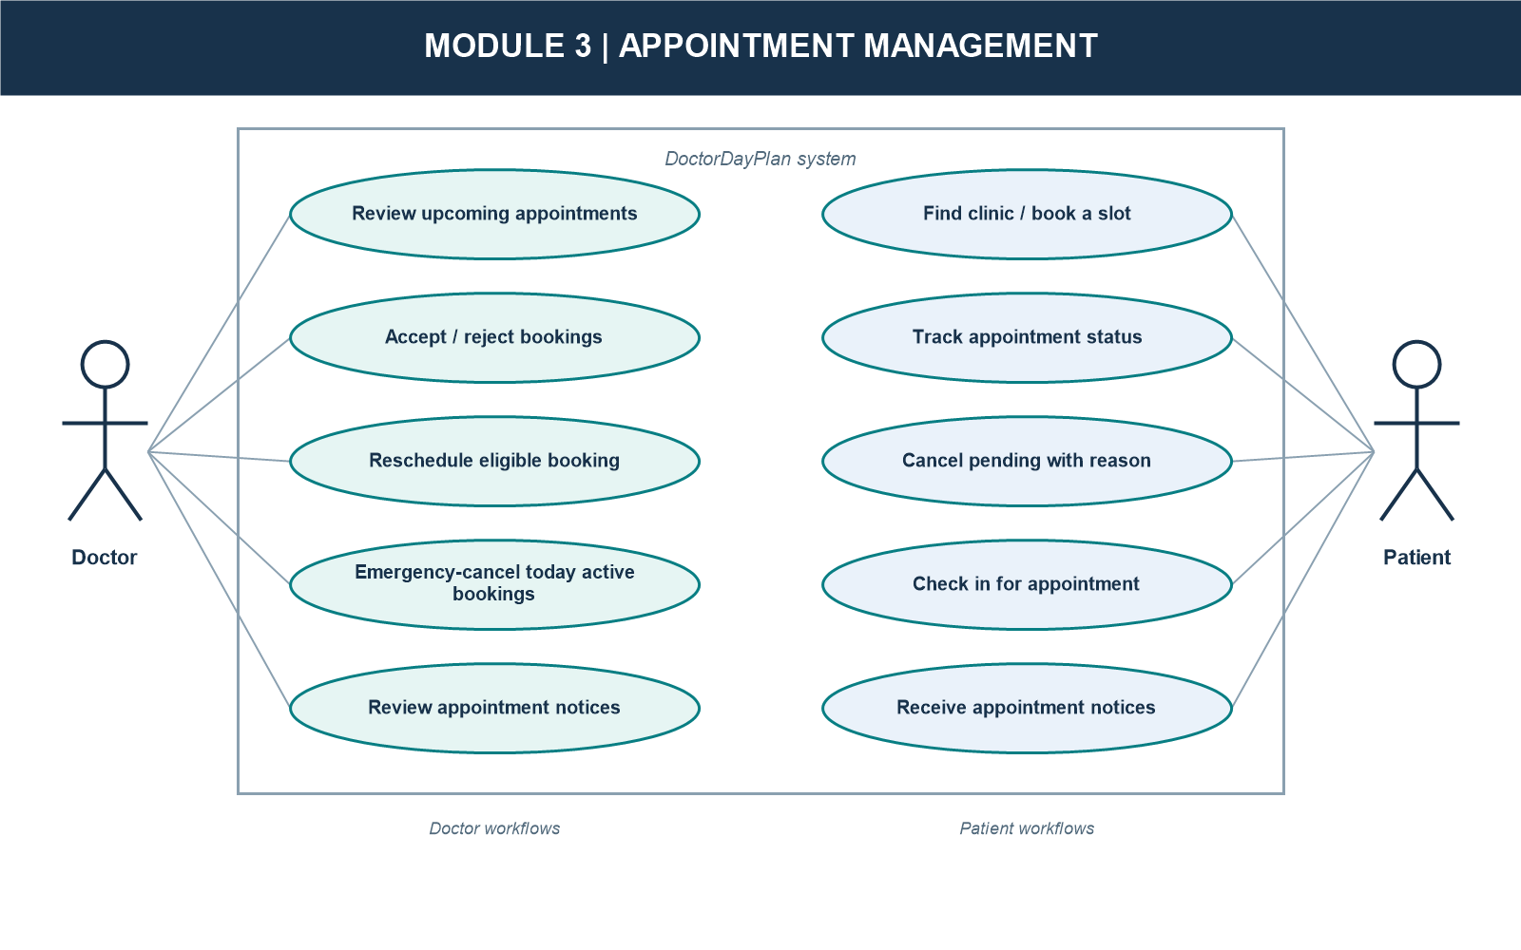

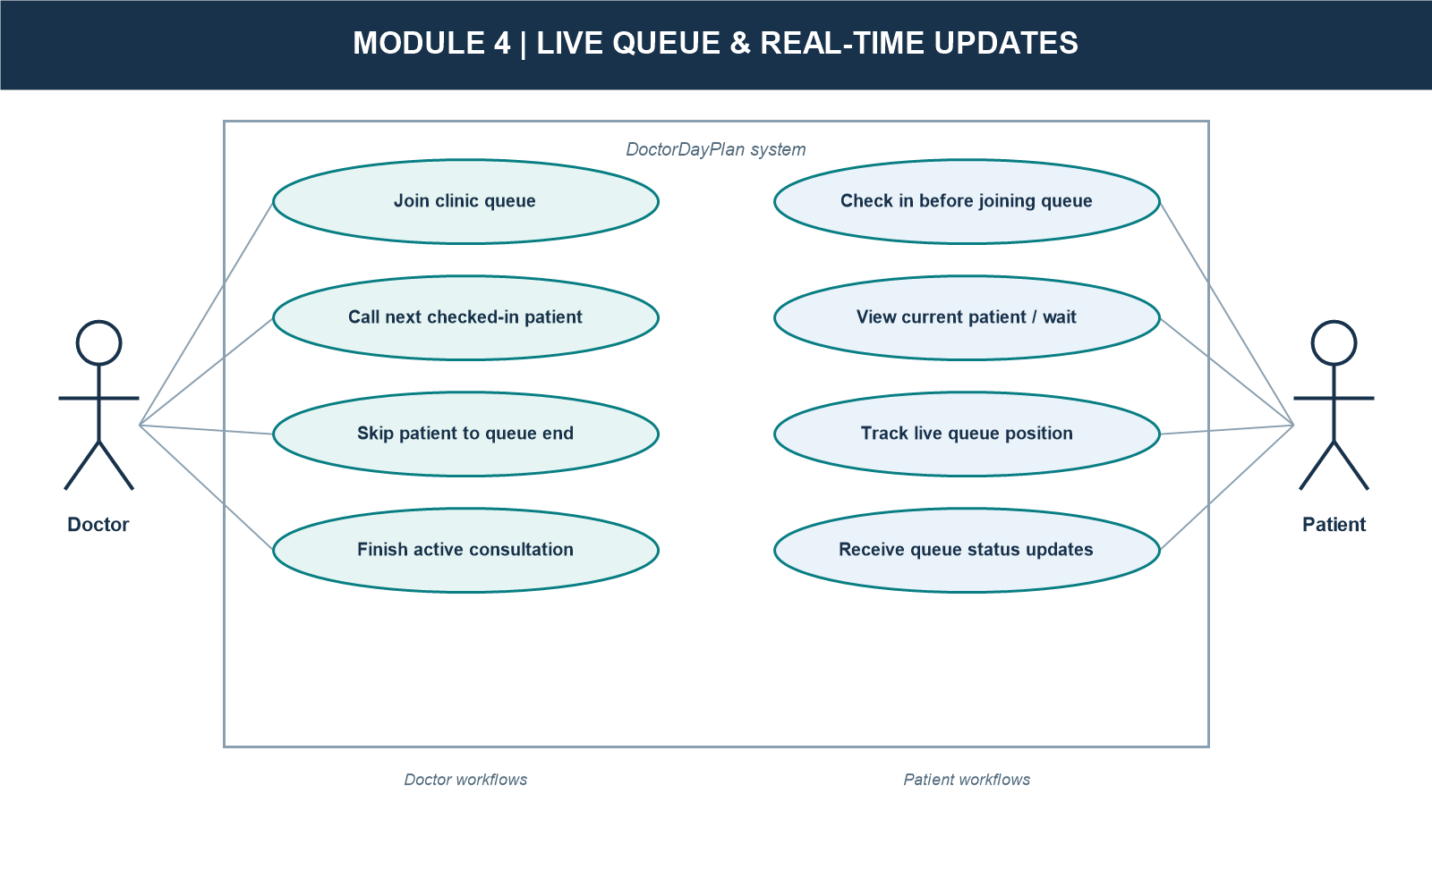

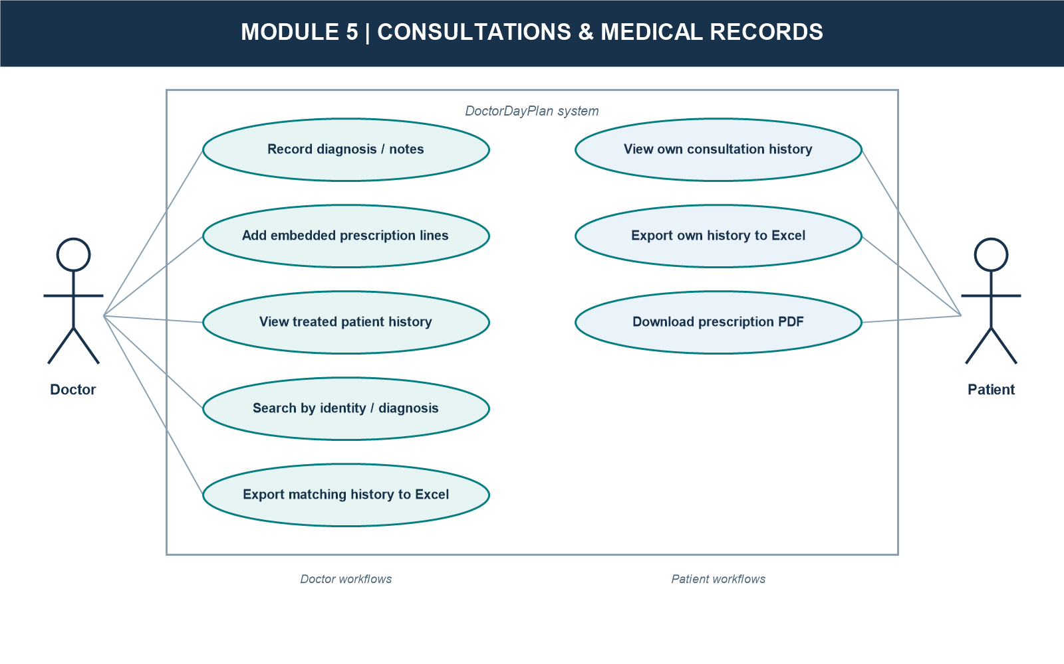

ER Diagram:
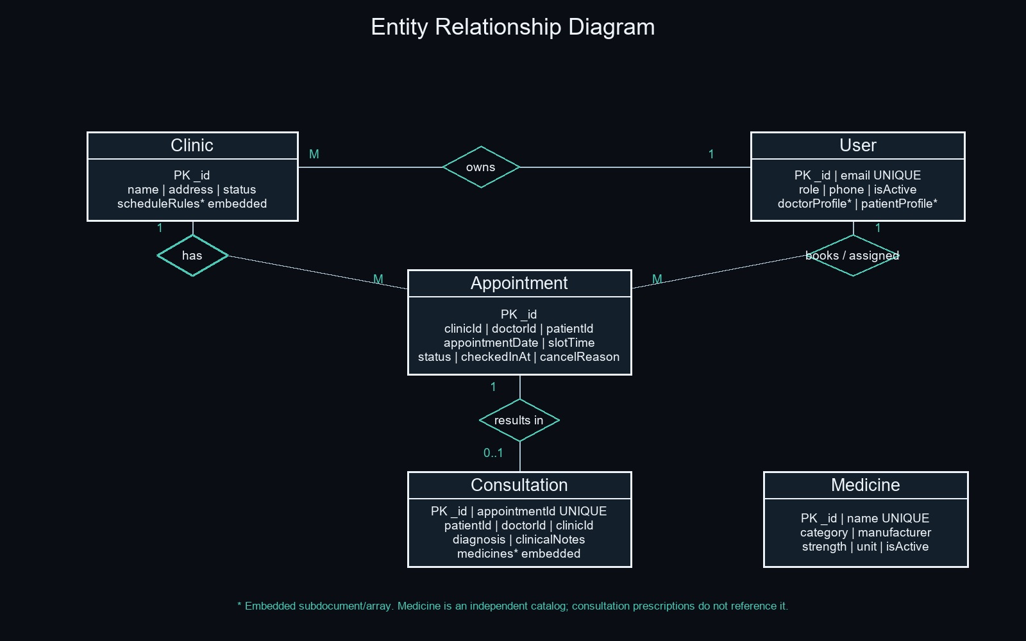

Data Dictionary
Collection 1: User
Purpose: Stores doctor and patient accounts, embedded role profiles, password hashes, account status, and private password-reset data.
Field | Type | Required | Default | Description
_id (PK) | ObjectId | Yes | Auto-generated | Primary document identifier.
email | String | Yes | None | Unique, lowercase, trimmed login email.
passwordHash | String | Yes | None | bcrypt hash; excluded from normal query results.
role | Enum String | Yes | None | doctor or patient.
phone | String | Patient: yes; doctor: no | None | Optional leading plus and 7-15 digits.
isActive | Boolean | No | true | Account activation state.
doctorProfile | Embedded Object | For doctors | Unset otherwise | Doctor profile; fields detailed below.
patientProfile | Embedded Object | For patients | Unset otherwise | Patient profile; fields detailed below.
passwordResetToken | String | No | None | SHA-256 hashed reset token; select:false.
passwordResetExpires | Date | No | None | Reset-token expiry; select:false; 15-minute lifetime.
createdAt | Date | Automatic | Current timestamp | Mongoose creation timestamp.
updatedAt | Date | Automatic | Current timestamp | Mongoose last-update timestamp.

doctorProfile (Embedded)
Field | Type | Description
name | String | Required, trimmed doctor name.
licenseNumber | String | Required; 2-5 letters, hyphen, 2-7 digits; sparse unique index.
specialization | String | Optional, trimmed medical specialization.
qualification | String | Optional, trimmed qualification.
experienceYears | Number | Optional; minimum 0.
bio | String | Optional, trimmed biography.
defaultSlotDurationMins | Number | Default 15; minimum 5.
avgConsultationMins | Number | Default 15; minimum 5.
unavailableDates | Array | Default []; entries contain required date and optional reason; embedded entry has no _id.

patientProfile (Embedded)
Field | Type | Description
name | String | Required, trimmed patient name.
dob | Date | Required date of birth.
gender | Enum String | Required; Male, Female, or Other.

Collection 2: Clinic
Purpose: Stores doctor-owned clinic locations, status, contact details, and weekly schedule rules.
Field | Type | Required | Default | Description
_id (PK) | ObjectId | Yes | Auto-generated | Primary document identifier.
doctorId | ObjectId ref User | Yes | None | Owning doctor; indexed.
name | String | Yes | None | Trimmed clinic name.
address | String | Yes | None | Trimmed clinic address.
contactPhone | String | No | None | Optional validated phone number.
status | Enum String | No | active | active or inactive.
scheduleRules | Array | No | [] | Weekly schedule; embedded rules detailed below.
createdAt | Date | Automatic | Current timestamp | Mongoose creation timestamp.
updatedAt | Date | Automatic | Current timestamp | Mongoose last-update timestamp.

scheduleRules (Embedded)
Field | Type | Description
dayOfWeek | String | Required; weekday name Monday through Sunday.
startTime | String | Required 24-hour HH:mm time.
endTime | String | Required 24-hour HH:mm time.

Collection 3: Appointment
Purpose: Stores appointment date/time, participants, status, check-in, and cancellation details.
Field | Type | Required | Default | Description
_id (PK) | ObjectId | Yes | Auto-generated | Primary document identifier.
clinicId | ObjectId ref Clinic | Yes | None | Clinic where the appointment is scheduled.
doctorId | ObjectId ref User | Yes | None | Doctor assigned to the appointment.
patientId | ObjectId ref User | Yes | None | Patient who booked the appointment.
appointmentDate | Date | Yes | None | Calendar date of the appointment.
slotTime | String | Yes | None | 24-hour HH:mm time, stored separately from appointmentDate.
status | Enum String | No | pending | pending, confirmed, inConsultation, rejected, cancelled, completed.
checkedInAt | Date | No | null | Check-in timestamp.
cancelReason | String | No | None | Optional trimmed cancellation reason.
createdAt | Date | Automatic | Current timestamp | Mongoose creation timestamp.
updatedAt | Date | Automatic | Current timestamp | Mongoose last-update timestamp.

Indexes and Uniqueness Constraints
Collection | Index Keys | Constraint / Purpose
User | email: 1 | Unique login email.
User | doctorProfile.licenseNumber: 1 | Unique sparse doctor license number.
Clinic | doctorId: 1 | Doctor clinic lookup.
Appointment | clinicId: 1, appointmentDate: 1, slotTime: 1 | Unique slot; prevents double booking.
Appointment | doctorId: 1, appointmentDate: 1 | Doctor appointment lookup.
Appointment | patientId: 1 | Patient appointment lookup.
Consultation | appointmentId: 1 | Unique; at most one consultation per appointment.
Consultation | patientId: 1, createdAt: -1 | Patient history ordering.
Consultation | doctorId: 1, createdAt: -1 | Doctor consultation lookup.
Medicine | name: 1 | Unique medicine catalog name.

Collection 4: Consultation
Purpose: Stores one consultation per appointment, including diagnosis, clinical notes, and embedded prescription lines.
Field | Type | Required | Default | Description
_id (PK) | ObjectId | Yes | Auto-generated | Primary document identifier.
appointmentId | ObjectId ref Appointment | Yes | None | Unique; consultation belongs to one appointment.
patientId | ObjectId ref User | Yes | None | Patient treated.
doctorId | ObjectId ref User | Yes | None | Doctor conducting the consultation.
clinicId | ObjectId ref Clinic | Yes | None | Clinic where consultation occurred.
diagnosis | String | Yes | None | Required trimmed diagnosis.
clinicalNotes | String | No | None | Optional trimmed clinical notes.
medicines | Array of embedded objects | No | [] | Lines contain name, dosage, durationDays, and optional instructions; embedded entries have no _id.
createdAt | Date | Automatic | Current timestamp | Mongoose creation timestamp.
updatedAt | Date | Automatic | Current timestamp | Mongoose last-update timestamp.

Collection 5: Medicine
Purpose: Stores the medicine catalogue. Consultation prescriptions are embedded line items with their own medicine name and dosage details.
Field | Type | Required | Default | Description
_id (PK) | ObjectId | Yes | Auto-generated | Primary document identifier.
name | String | Yes | None | Trimmed, unique medicine name.
category | Enum String | Yes | None | Tablet, Capsule, Syrup, Injection, Ointment, Drops, Inhaler, or Other.
manufacturer | String | No | None | Optional trimmed manufacturer.
strength | String | No | None | Optional trimmed strength.
unit | Enum String | No | None | Optional: mg, ml, g, mcg, or IU.
isActive | Boolean | No | true | Catalogue active state.
createdAt | Date | Automatic | Current timestamp | Mongoose creation timestamp.
updatedAt | Date | Automatic | Current timestamp | Mongoose last-update timestamp.

